# Examples

# Consider the following system snapshot using data structures in the Banker’s algorithm, with resources A, B, C, and D, and process P0 to P4

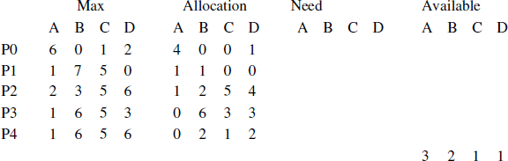

Using Banker’s algorithm, answer the following questions.

|  |  |  |
| --- | --- | --- |
| (i) | How many resources of type A, B, C, and D are there? | (2) |
| (ii) | What are the contents of the Need matrix? | (2.5) |
| (iii) | Is the system in a safe state? Why | (3) |
| (iv) | If a request from process P4 arrives for additional resources  Banker’s algorithm grant the request immediately? Show the other criteria. | of (1,2,0,0,), can the new system state and  (5) |
| Ans: |  |  |
| (i)  (ii) | A-9; B-13;C-10;D-11 |  |

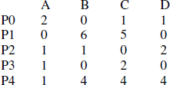

* 1. The system is in a safe state as the processes can be finished in the sequence P0, P2, P4, P1 and P3.
  2. If a request from process P4 arrives for additional resources of (1,2,0,0,), and if this request is granted, the new system state would be tabulated as follows.

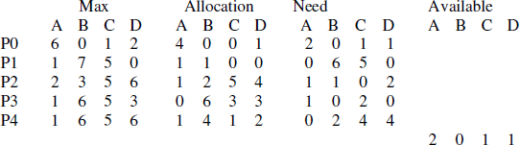

After PO completes P3 can be allocated. 1020 from released 6012 and available 2011(Total 80

23) and <Po, P3, P4, P2, P1> is a safe sequence.